LAB 3: Using EF Core CLI to Create and Apply Migrations
Aim
To use Entity Framework Core CLI to create and apply database migrations in SQL Server.

Objective
- Install the EF Core CLI tool.
- Create an initial migration.
- Apply the migration to create the database.
- Verify the database and tables in SQL Server.

Tools Required
- Visual Studio Code
- .NET SDK
- SQL Server Express
- SQL Server Management Studio (SSMS)
- Entity Framework Core

Procedure
Step 1: Install EF Core CLI
Installed the Entity Framework Core CLI tool using the following command:
dotnet tool install --global dotnet-ef

Step 2: Create Initial Migration
Created the initial migration using the following command:
dotnet ef migrations add InitialCreate
This command generated the Migrations folder containing migration files.
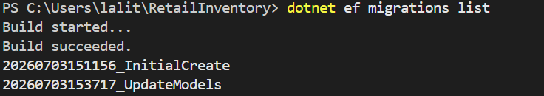Note: Since you had already created InitialCreate, you can instead use:
dotnet ef migrations list

Step 3: Apply Migration
Applied the migration to the database using:
dotnet ef database update
This command created/updated the RetailInventoryDB database in SQL Server.
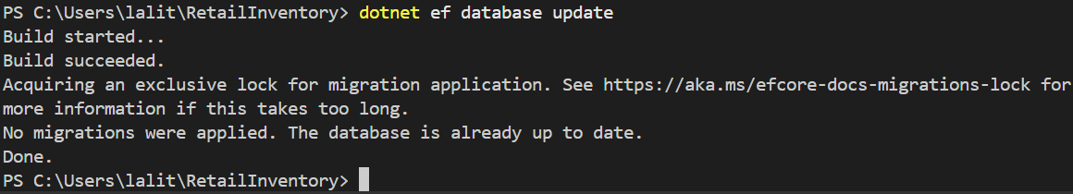
Step 4: Verify Database
Opened SQL Server Management Studio (SSMS) and verified that the database and tables were created successfully.
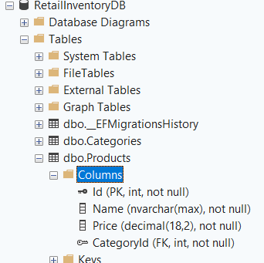
Result
The Entity Framework Core migration was successfully created and applied. The RetailInventoryDB database and the required tables were successfully created in SQL Server.

